January 9, 1916
Covenant Through the Prophets Refers Only to the Holy Prophet Muhammad
I bear witness that none deserves to be served besides Allah and I bear witness that Muhammad is the servant and messenger of Allah. —
After this, I seek the protection of Allah from the accursed devil.
In the name of Allah, the Beneficent, the Merciful.
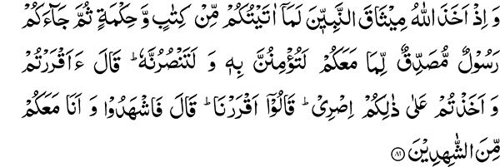
“And when Allah made a covenant through the prophets: Certainly what I have given you of Book and Wisdom — then a Messenger comes to you verifying that which is with you, you shall believe in him, and you shall aid him. He said: Do you affirm and accept My compact in this (matter)? They said: We do affirm. He said: Then bear witness, and I (too) am of the bearers of witness with you.” (3:81)
“Whoever then turns back after this, these are the transgressors.” (3:82)
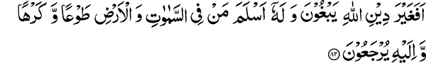
“Seek they then other than Allah’s religion? And to Him submits whoever is in the heavens and the earth, willingly or unwillingly, and to Him they will be returned.” (3:83)
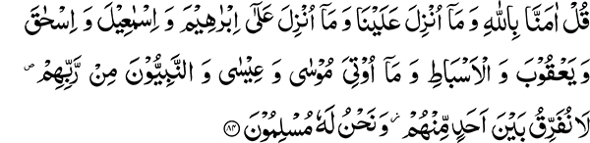
“Say: We believe in Allah and that which is revealed to us, and that which was revealed to Abraham and Ishmael and Isaac and Jacob and the tribes, and that which was given to Moses and Jesus and to the prophets from their Lord; we make no distinction between any of them, and to Him we submit.” (3:84)
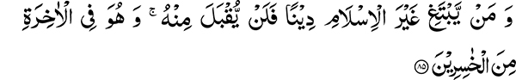
“And whoever seeks a religion other than Islam, it will not be accepted from him, and in the Hereafter he will be one of the losers.” (3:85)
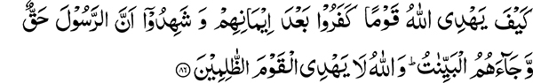
“How shall Allah guide a people who disbelieved after their believing, and (after) they had borne witness that the Messenger was true, and clear arguments had come to them? And Allah guides not the unjust people.” (3:86)
“As for these, their reward is that on them is the curse of Allah and the angels and of men, all together —” (3:87)
“Abiding therein. Their chastisement shall not be lightened, nor shall they be respited—” (3:88)
“Except those who repent after that and amend, for surely Allah is Forgiving, Merciful.” (3:89)
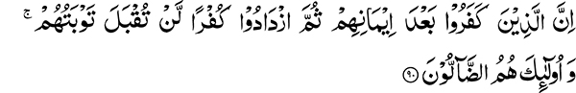
“Those who disbelieve after their believing, then increase in disbelief, their repentance is not accepted, and these are they that go astray.” (3:90)
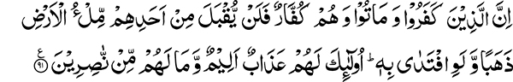
“Those who disbelieve and die while they are disbelievers, the earth full of gold will not be accepted from one of them, though he should offer it as ransom. These it is for whom is a painful chastisement, and they shall have no helpers.” (3:91)
Misinterpretation of the Holy Quran
People have adopted a way of interpreting the Quranic word whereby, in order to elevate the status of an individual, they try to apply different verses of the Holy Quran to support them. Similarly, when they want to denigrate and vilify someone, they attempt to derive support for their contention from every word and letter of the Holy Quran. Those who have read the commentaries of the Shia (sect) are well aware of how the Quranic word is used to elevate the status of Hazrat Ali and Imam Hussein and malign Hazrat Abu Bakr. Our brethren have gone even a step farther. The Shia could be considered somewhat handicapped in this matter because they have deduced their interpretations from some words that are very complicated and they do not place the burden of proof for their comments upon a decisive verse of the Holy Quran. Instead they (our brethren) take those verses of the Holy Quran that clearly refer to the Holy Prophet Muhammad and apply them to Hazrat Mirza Ghulam Ahmad Sahib. This is an extremely dangerous path they have adopted and it is our duty to call it faulty and defective.
When we do not shirk from pointing out even minor defects of others’ arguments, it behooves us to point out what is defective within a faction of our own community and is liable to lead in a very wrong direction. For example, if a Shia interprets the huruf-i-muqatta‘at (abbreviated words) kaf ha ya ain sad (19:1) as kaf for karbala, ha for the halaqat (killing) of the ahle beit ya for yazid etc., although this interpretation may be incorrect, nevertheless it relates to abbreviations where there may be some limitations regarding their meaning. If someone tries to prove by using the same methodology that Hazrat Mirza Ghulam Ahmad was a prophet, it may also to some degree, be regarded as a similar handicap. On the other hand, if one takes a decisive verse that clearly applies to the Holy Prophet Muhammad and tries to use it to prove that Hazrat Mirza Ghulam Ahmad was a prophet, then it is clearly making a mockery of the Holy Quran and denigrating the Holy Prophet Muhammad (peace and blessings of Allah be upon him).
The Covenant Through the Prophets
“And when Allah made a covenant through the prophets…” What is meant by ‘covenant through the prophets’ in this verse? The next verse tells us it means that they are taking a covenant from their followers, for the prophets themselves would not be alive when the time came to honor this pledge. For this reason, the prophets took a pledge from their nations; and Allah the Most High calls it the covenant through the prophets. The Holy Quran tells us what the covenant was:
“Certainly what I have given you of Book and Wisdom — then a Messenger comes to you verifying that which is with you, you shall believe in him, and you shall aid him. He said: Do you affirm and accept My compact in this (matter)? They said: We do affirm. He said: Then bear witness, and I (too) am of the bearers of witness with you.” (3:81)
A Voice of Vilification Arises from Hyderabad Deccan
Who is this prophet about whom this pledge was taken? It is quite obvious that this covenant refers to the Holy Prophet Muhammad. Now an individual from Hyderabad Deccan made the statement in one of his sermons that the words, “then a Messenger comes to you verifying that which is with you,” refer not to the Holy Prophet Muhammad but to Hazrat Mirza Ghulam Ahmad. This statement clearly disparages the Holy Prophet Muhammad. It was our hope that it would be strongly condemned. Recently, a translation and commentary of the first part of the Holy Quran was published by Mian Mahmud Ahmad, and quite contrary to our expectations, it supports this interpretation. In it, the verse “Of the Hereafter (al-akhira) they are sure,” (2:4) al-akhira has been interpreted as referring to the revelation of Hazrat Mirza Sahib and the verse about the covenant of the prophets is presented as proof for this interpretation. This is clear mockery and a derision of the Holy Prophet.
Sometimes people make a statement about the Holy Quran that is in subservience to their own thought process. It becomes the duty of others to reject this. In this case, to the contrary, it is receiving support. I am also an Ahmadi and believe that this is a lie and a false accusation against Hazrat Mirza Ghulam Ahmad. The writings of Hazrat Mirza Ghulam Ahmad are spread over eight thousand pages. I challenge any individual to show anywhere in his writings where he has supported this interpretation. The newspapers of Al-Hakam and Al-Badr are full of Hazrat Mirza Sahib’s diaries. Can anyone provide proof from these where he interpreted this verse as referring to himself? There is certainly not a single word in these writings and speeches where even a remote hint of such meaning is found. If they have any fear in their hearts of Allah and His messenger, the Holy Prophet Muhammad, they should desist from such willful libel and vilification of the Holy Quran and the Holy Prophet.
Who is the Prophet who Confirmed the Prophet-hood of all Previous Prophets?
This statement is quite simple and easy to understand, “— then a Messenger comes to you verifying that which is with you” (3:81). Go and search the historical record in all corners of the world. Who is the Prophet who came into this world and for the first time confirmed all the prophets before him? You will find none other than the Holy Prophet Muhammad who fulfills this prophecy. This is confirmed by the verse that follows:
“Say: We believe in Allah and that which is revealed to us, and that which was revealed to Abraham and Ishmael and Isaac and Jacob and the tribes, and that which was given to Moses and Jesus and to the prophets from their Lord; we make no distinction between any of them, and to Him we submit.” (3:84)
This is the verification of all the prophets before him; this was done by the Holy Prophet Muhammad.
Prophecies about the Holy Prophet Muhammad in the Books of Previous Prophets
The prophets who came into this world before the Holy Prophet Muhammad made prophecies about his advent. We can find and read these references in the books of these prophets.
Thus, through Moses, Almighty God had warned the Israelites, after promising them “a prophet from among their brethren like unto thee,” that “Whosoever will not hearken unto My words which he shall speak in My name, I will require of him” (Deut. 18:19).
David’s psalms (Zabur) clearly sing praises of the Holy Prophet Muhammad and Jesus was equally emphatic when prophesying the advent of the Comforter he added: “He will guide you into all truth; for he shall not speak of himself, but whatsoever he shall hear, that shall he speak” (John 16:13). Similarly, other scriptures also mention the Holy Prophet Muhammad. All this clearly identifies who the Messenger is as referred to in, “— then a Messenger comes to you,” about whom a covenant was made through the prophets. On the one hand, all these prophets confirmed the truthfulness of the Holy Prophet Muhammad and Holy Prophet Muhammad confirmed the truth of all these prophets in these words, “verifying that which is with you.”
Hazrat Mirza Ghulam Ahmad Sahib is Dependent upon the Holy Prophet Muhammad for his Own Confirmation
Go and search the world over. Who is the first person who in accordance with the Quranic statement, “verifying that which is with you,” confirmed the truthfulness of all the prophets before him? Besides the Holy Prophet Muhammad, you will find no one else fulfilling this prophecy. The name of the one who was the first one to do this verification is not there today; his place was given to Hazrat Mirza Sahib. You do not even realize that Hazrat Mirza Sahib is himself dependent upon the Holy Quran for confirmation of his own truthfulness. We consider Hazrat Mirza Sahib as truthful only because his truth is confirmed by the Quran and Hadith. The revelation of Hazrat Mirza Sahib is not acceptable until confirmed by the Holy Quran and Hadith. Hazrat Mirza Ghulam Ahmad Sahib himself made the Quran and Hadith the standard whereby he verified what was revealed to him.
How can someone who is dependent upon others for his verification be the one, “verifying that which is with you.” Come! Refrain from this great inequity and do not give the slave status of the master. You apply the prophecies about the Holy Prophet Muhammad to Hazrat Mirza Ghulam Ahmad. This is a very dangerous path and you should desist from it. Remember, Hazrat Mirza Ghulam Ahmad Sahib is not the one who verifies the Holy Quran but relies upon the Holy Quran for verification of his own truthfulness. He never said that you should believe in the Holy Quran because my revelation verifies it to be the truth. On the contrary, he said you should believe in me because the Holy Quran confirms my truthfulness. He repeatedly gave evidence from the Holy Quran to prove the truthfulness of his revelations and never sought direct confirmation and acceptance for them.
Nor did he state that I have come to verify the Holy Quran. Decide this question first. Did Hazrat Mirza Ghulam Ahmad Sahib come to verify the Holy Quran or was he dependent upon the Holy Quran for his own verification? Just randomly making a statement that he was the subject of this prophecy is the greatest inequity. This is the action that the Holy Quran describes in these words, “Whoever then turns back after this, these are the transgressors” (3:82). For the last two years, they have been calling us transgressors, while according to this verse those who turn back from this prophecy are called transgressors. We don’t know who they are. They can decide for themselves who is guilty of transgression according to these words of the Holy Quran.
“Seek they then other than Allah’s religion? And to Him submits whoever is in the heavens and the earth, willingly or unwillingly, and to Him they will be returned.” (3:83)
The Verse of, “Covenant through the Prophets,” Does Not Apply to Hazrat Mirza Ghulam Ahmad
“Say: We believe in Allah and that which is revealed to us.” In conjunction with this the Holy Prophet confirms,
“…that which was revealed to Abraham and Ishmael and Isaac and Jacob and the tribes, and that which was given to Moses and Jesus and to the prophets from their Lord; we make no distinction between any of them, and to Him we submit.” (3:84)
Just naming a few of the prophets does not complete the list; therefore the Holy Quran tells us, “and (We sent) messengers We have mentioned to thee before and messengers We have not mentioned to thee” (4:164)
This is why after mentioning a few names, the Holy Quran states: “And to the prophets from their Lord.” This is the verification made by the Holy Prophet Muhammad of all the prophets before him. Did Mirza Sahib first make this confirmation or was the Holy Prophet the first one to do so?
“…We make no distinction between any of them, and to Him we submit.” (3:84)
“And whoever seeks a religion other than Islam, it will not be accepted from him, and in the Hereafter he will be one of the losers.” (3:85)
Islam Means Complete Submission
What is Islam? Complete submission to Allah is Islam. Regarding anyone who does not submit completely and has some other goals, the Holy Quran states, “It will not be accepted from him, and in the Hereafter he will be one of the losers.” You should also search your souls. Those of you who stay away from Islam will also be losers. Every individual should recognize that the part of his life that is not in submission to the will and pleasure of Allah, is not Islam and will be the source of difficulty for him. Do not consider Islam as the mere possession of a copy of the Holy Quran, and recitation of the formula of faith, “none deserves to be worshipped besides Allah and Muhammad is the messenger of Allah.” In fact, any of your deeds that do not seek the pleasure of Allah and are against His will are, “other than Islam,” and will undoubtedly be of no benefit. Once again, I remind you to search your souls to find out what is other than Islam that lies within you or is part of your deeds. Extricate this from your souls and submit fully to Allah the Most High.
“As for these, their reward is that on them is the curse of Allah and the angels and of men, all together —Abiding therein. Their chastisement shall not be lightened, nor shall they be respited.” (3:87-88)
Consequences of Abandoning Islam is Becoming Remote from it (Curse of Allah)
This is a very strong edict, for there can be no greater hell than becoming remote from Allah the Most High, from whom flows the fountainhead of all purity. One also becomes remote from the angels who inspire goodness and can therefore not benefit from their inspiration. Neither can one benefit from the righteousness of the pious and pure in the world because of the widening gulf of separation. This is the real hell that arises as a consequence of distancing oneself from all the sources of goodness, giving up the good deeds and wishing for, “other than Islam.”
“Except those who repent after that and amend, for surely Allah is Forgiving, Merciful” (3:89). God is not so unjust as to forgive those who repent, but repentance must be accompanied with reformation and performance of good deeds.
Seek Repentance, for the Door of Repentance is Wide Open
Allah’s forgiveness encompasses all. Whenever someone knocks at His door, He is ready to open it. The Holy Quran states in other verses,
“…And despair not of Allah’s mercy. Surely none despairs of Allah’s mercy except the disbelieving people.” (12:87)
“Say: O My servants who have been prodigal regarding their souls, despair not of the mercy of Allah; surely Allah forgives sins altogether. He is indeed the Forgiving, the Merciful.” (39:53)
Indeed it is a very wide door, ready to admit anyone when he seeks entry into it. Do not put this off for the Holy Quran warns, “Those who disbelieve after their believing, then increase in disbelief, their repentance is not accepted, and these are they that go astray.” A time comes when a person has advanced so far in disbelief that even if he wants to give up evil, he cannot and repentance is of no avail.
Abstain From Evil for Every Evil Deed Leads to Disbelief
Disbelief does not only mean disbelief in the Holy Prophet Muhammad. Whatever kind of evil deed is done, the corresponding kind of disbelief evolves in a person’s soul. You may reach the stage in which you cannot get rid of evil even though you so desire. Refrain from it now and prevent it from growing. We have observed people who continue to smoke the hookah while nearby the prayer service is going on. It is not that they are hostile toward Islam. In fact, if you listen to them, they seem to be enthusiastic admirers. Their practical condition is however such that in spite of being aware of the prayer service they do not care and never participate. Every individual should be concerned about himself for if he delays the doing of good for another day, he is nurturing a seed that will become firmly rooted and hard to get rid of.
“Those who disbelieve and die while they are disbelievers, the earth full of gold will not be accepted from one of them, though he should offer it as ransom” (3:91). What do you gain if you abandon Islam? Why do you give up piety? Is it for the sake of monetary gain? If so, how much will you gain? You certainly do not get the earth full of gold. In fact you do not even get half or one third. A time will come when even the earth full of gold will be of no benefit to you. Nothing can save you from death; therefore be concerned. If you have huge tracts of farmland or have large sums of money or personal property, none of these can save you from death.
Death is for Certain; be Prepared Ahead of Time
It is very surprising that although death is the most certain event in our life, and we see our friends departing every day, nevertheless we are still oblivious to our mortality. Even on our death beds, we hope to live longer. Be cognizant of this eventuality. All this material wealth will be of no benefit to you when you die. Try to reform yourself whether you are a male, a female, adult or child. Everyone should be concerned that their condition may not reach a stage when it would be difficult to get rid of evil. Stay away from evil.
May Allah the Most High protect our hearts and our faculties in such a manner that they do not get inclined toward evil deeds or wrong beliefs. Wrong beliefs and misdeeds are at par. In fact, belief is like a seed: If the seed is defective, the plant that arises from it will also be unhealthy. Therefore, correct both: your beliefs and your deeds.

This refers to followers of Mian Mahmud Ahmad after the split in the Ahmadiyya Movement in 1914.
Mir Muhammad Saeed of Hyderabad Deccan, a follower of Mian Mahmud Ahmad.

